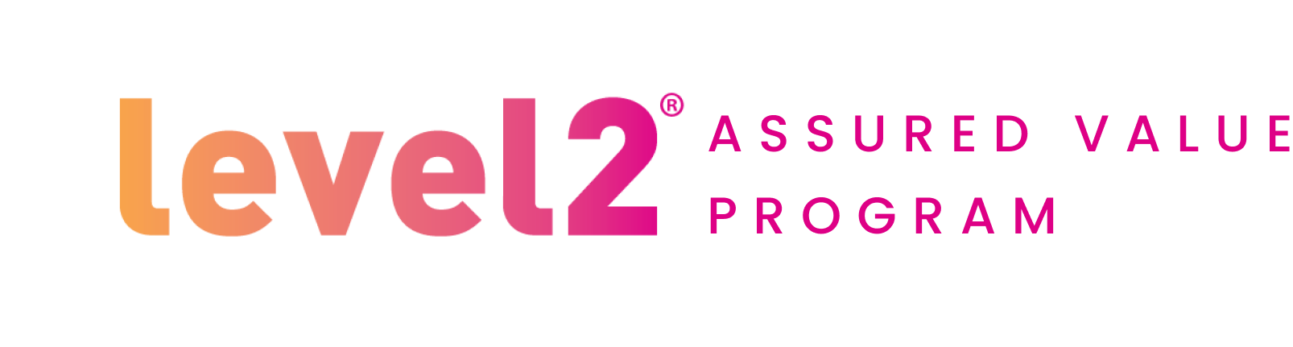

**Employer Letter to Employees about Level2 Assured Value Program**

Subject Line: Did you know this was made for YOU?

Pre-header: Something new at no additional cost.

Dear employee,

At <Company Name> we are all about helping you live a happy and healthy life.

This year, we’re pleased to share that your health plan benefits now include access to Level2 Specialty Care, a program to help you or any adult on your plan who is living with type 2 diabetes.

Level2 works with people to help them as they work to improve their type 2. Plus, all this at no additional cost:

* Insights: You’ll start with a continuous glucose monitor (CGM) to learn what works for you.
* Care Team: Virtual access to a care team of experts including providers, nurses and dietitians, all ready to guide you.
* Level2 Method: A defined process to help you understand and work to improve glucose control in a series of phases.

Learn about this new benefit at mylevel2.com/care or give Level2 Specialty Care a call toll-free at 1-844-302-2821, TTY 711.

Your team at <Company Name>